Prompt Suggestions and Bugs

- I set up a new account and put in my Dolor email (georgina@dolorgroup.co.uk) and password. It sent a verification code to my email (which didn’t go to junk) but then when I switched back to the Prompt page to enter my code it was on this page:
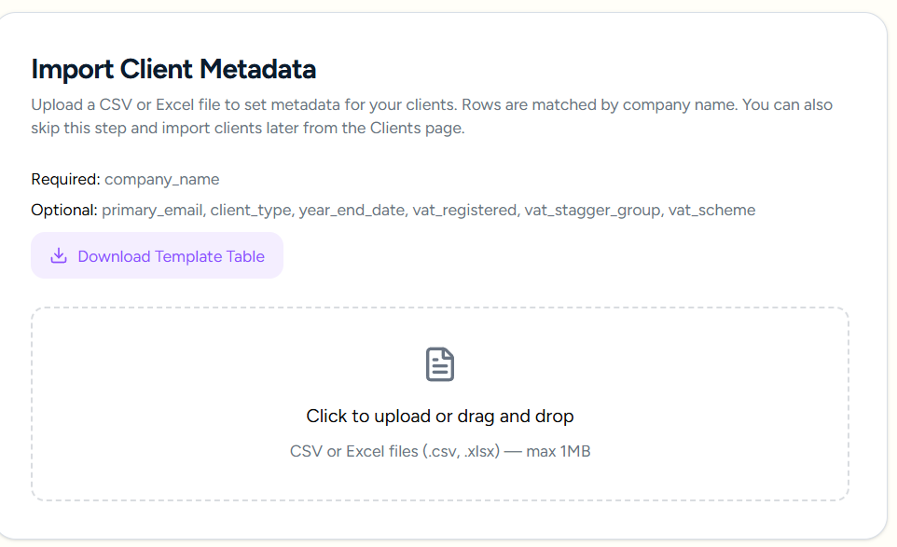
I couldn’t seem to go back through the website to get to the Verify page, although it looks like you should as ‘Verify’ gets underlined when you hover on it.

WHen I clicked ‘back’ it went to the Choose your plan page, but there isn’t a ‘back’ button on that page.

- CLIENT SET UP
Best if the search box says ‘client name’ not company name. I was about to upload some individual clients, e.g. Chris Schoeb, with self-assessment reminders
- Same issue when you open up the Add Client box.

14 March 2026:
GETTING STARTED:
The Getting Started button is great and very intuitive after signing up. I did the first step to add some clients, but then it would be helpful to know how to continue, e.g. ‘Return to Getting Started’ or ‘Getting started – next step’ or something.
CREATE AN EMAIL TEMPLATE:
I went back to Dashboard and clicked on Get Started again, and chose ‘create an email template’, which I’m guessing will be most people’s next step. It then opened on the Settings page rather than the Email Templates page.
CUSTOM EMAILS
iT’S brilliant and I’ve draft an email for the new quarterly reporting that I will be using. I couldn’t seem to add a variable into the email header though.
URL link
I clicked on the URL button and inserted the ICAEW’s guidance on the quarterly return process but can’t see where that goes in the email template. I was hoping to put it in the email - see where I’ve put a sentence about it.
RETURN TO QUICK START
As before - I wasn’t sure how to go from there to the next step of Getting Started, but TBH I instinctively clicked back to Dashboard which is what most people will do.
NEW DEADLINE FOR ALL CLIENTS FOR NEW MDT QUARTERLY REPORTING
I wrote my email and then wanted to attach the deadline to it and be able to send it, but couldn’t see how to make a deadline that isn’t already in your deadline schedule. So I think you need to add another standard deadline for individuals called something like Quarterly MDT for Income Tax. You can see what people like Quickbooks / Free Agent etc have called it.
The quarters will run like tax years, i.e. ending UK MTD for Income Tax for a sole trader, the quarterly update deadlines are:
- quarter to 5 July 2026 → due 7 August 2026
- quarter to 5 October 2026 → due 7 November 2026
- quarter to 5 January 2027 → due 7 February 2027
- quarter to 5 April 2027 → due 7 May 2027
Then the year-end tax return/finalisation for the 2026/27 tax year is due by 31 January 2028. If you are entering MTD from April 2026, you still file the 2025/26 return in the normal way by 31 January 2027.

REVIEW OF HOME PAGE:
It’s really good!
My only concern is that I think lots of accountants are quite risk averse, so it would be good to stress the optional nature of the more integrated features, so they know they could just limit it to sending deadline reminders (especially at first), and that it won’t be too complex to set up.
So with the 6 initial boxes (which are really good) it could help to have the three first - i.e. Deadline tracking, automated reminders and Email Management,
And then have added optional features with the other three boxes. Even withinEmail Management, it could be good to tweak to ‘Send from Prompt’s portal or your own domain …’
On ‘Deadline tracking’ I would change ‘corporation tax, CT600s,’ to just ‘corporation tax returns, as they’re the same thing.
I would put ‘optional’ by ‘Client Upload Portal’
Prompt vs the Old Way:
I’d change it to ‘Corporation tax payments, CT600s, VAT..
VAT - I would remove ‘all three HMRC groups supported’ , and also remove that clause from ‘What deadlines does Prompt track’
Confirmation statements - where it says ‘ you never enter a date manually’ you may want to remove that as each company has a different confirmation statement date so they will have to enter it manually at some point - unless Prompt can look it up from the Companies House website - like your company here, where you’ll see the confirmation statement deadline on the main page:
PROMPT AUTOMATION LTD overview - Find and update company information - GOV.UK

CLIENT MANAGEMENT PAGE:

CT600 filing - you could remove ‘Statutory accounts’ because this is something the accountant will prepare.

Companies House accounts:
- The confirmation statement and PSC register are different deadlines. The PSC register is part of the confirmation statement process. This would need to be a separate deadline (like you just created for quarterly MDT for income), as it’s completely separate to filing the accounts.
- The deadline for each company’s confirmation statement is on the Companies House website, or they could input it.
- I wouldn’t bother with the PSC register as a separate deadline.

EMAIL LOG
As we talked about - it would be great if the email log showed the individual template in the template column, e.g. Companies House accounts - 1st reminder

19 March 2026

For partnerships you only need Partnership Tax Return and VAT Return. The quarterly MDT thing isn’t affecting partnerships at the moment and the other deadlines like payroll aren’t relevant.

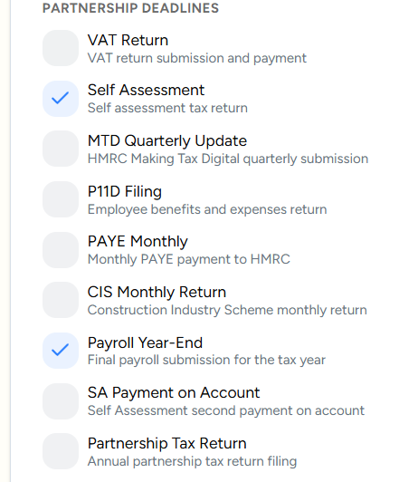

For individuals: You just need Self Assessment, MDT Quarterly Return (not update), SA payment on account and Trust Tax Return

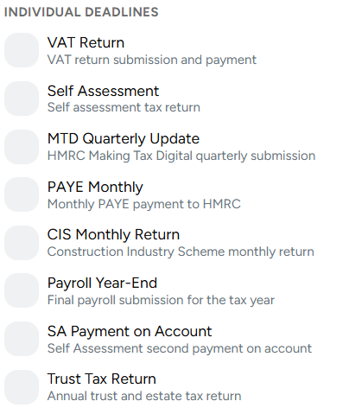

I think it would be good to tweak this to ‘these form the checklist that clients see on their reminder emails and the upload portal (optional).

On the list below I don’t think you need most of the items (these are the accountants’ jobs). You just need the bank statements .

Could you change that line to ‘Provide full year statements’ to ‘Provide full year transaction download in Excel or csv format’.

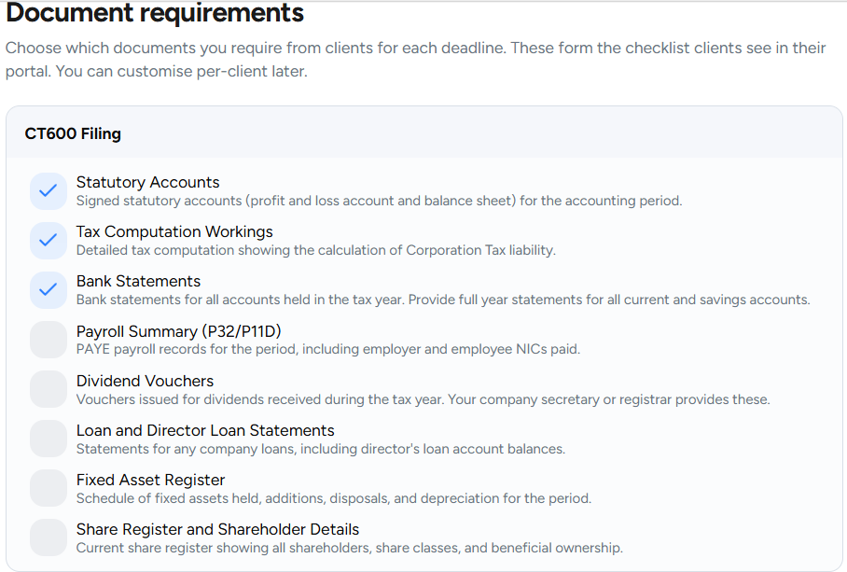

I would also move the Companies House accounts box to above the CT600 box, as (a) you need to do it first and then attach it to the CT600, and (b) the deadline is earlier. Then for the Companies House box I would have the bank statements line, not for the CT600 box.

I would include Dividend Vouchers, Loans & Director Loan Statements ad the Fixed Asset register in the Companies House accounts box.

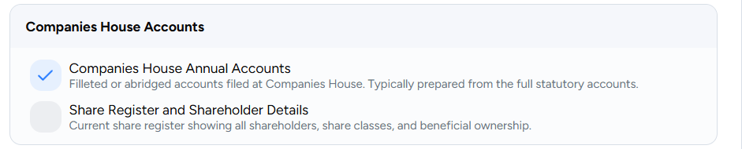
I would also have a line for ‘Adjustments: Schedule of business transactions paid/received from personal accounts which need including in the accounts.’

I would remove the 2 items currently in Companies House Annual Accounts, as you wouldn’t be asking them for the accounts (you would prepare it), and the share register is needed for the confirmation statement.

For the confirmation statement box - the accountant would hold things like the share register. So the most helpful thing would be for them to review the information currently held on Companies House and inform the accountant of any changes to the share register and shareholder details / PSC register / directors / registered office address.

So it could just say something like:

Company changes: Confirmation of any changes to the share register and shareholder details / PSC register / directors / registered office address.

Or the detail for the client could direct them Search the register - Find and update company information - GOV.UK

Then input their company name, clicking on Filing History and then last year’s confirmation statement.

Patnership tax return:

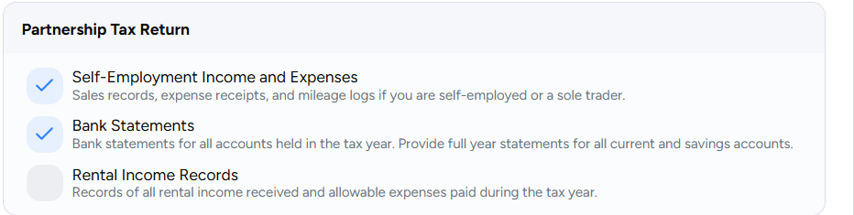
Change the bank statements line as above to mention csv/Excl
You can remove the rental income records
Add in Mileage log as a separate item

Self-Assessment:
I would put this above partnerships and have the following:

- P60s, P45s and P11Ds from all employments during the year
- Self-assessment questionnaire: Complete our questionnaire on standard sections such as donations, pension contributions etc.
- Sole trader section: Bank statement download for tax year, plus schedule of business transactions paid/received from personal accounts.
- Rental income section: Complete our questionnaire
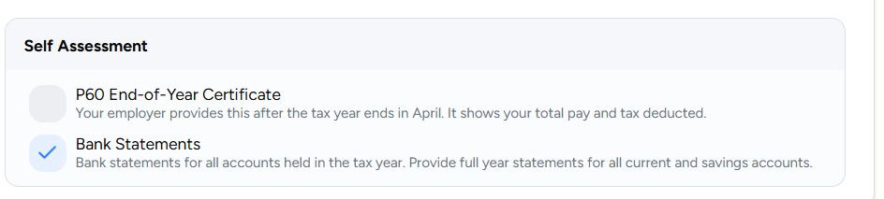

VAT: Also need to include this somewhere as a separate

